# **Protozoa**

# **Amoebae**

### **Entamoeba histolytica**

* **Epidemiology**: Worldwide; tropics, poor sanitation.
* **Transmission**: Ingestion of cysts (faeco-oral).
* **Clinical**: Amoebic dysentery; amoebic liver abscess ("anchovy sauce pus"); rare pulmonary/brain spread.
* **Diagnosis**:
  + Microscopy (trophozoites with ingested RBCs).
  + PCR/antigen (distinguishes from *E. dispar*).
  + Serology (useful in liver abscess).
  + Imaging (US/CT) helpful in detecting liver abscess.
* **Treatment**:
  + Metronidazole + luminal agent (paromomycin/diloxanide).
  + Drain abscess if risk of rupture or poor response to therapy;

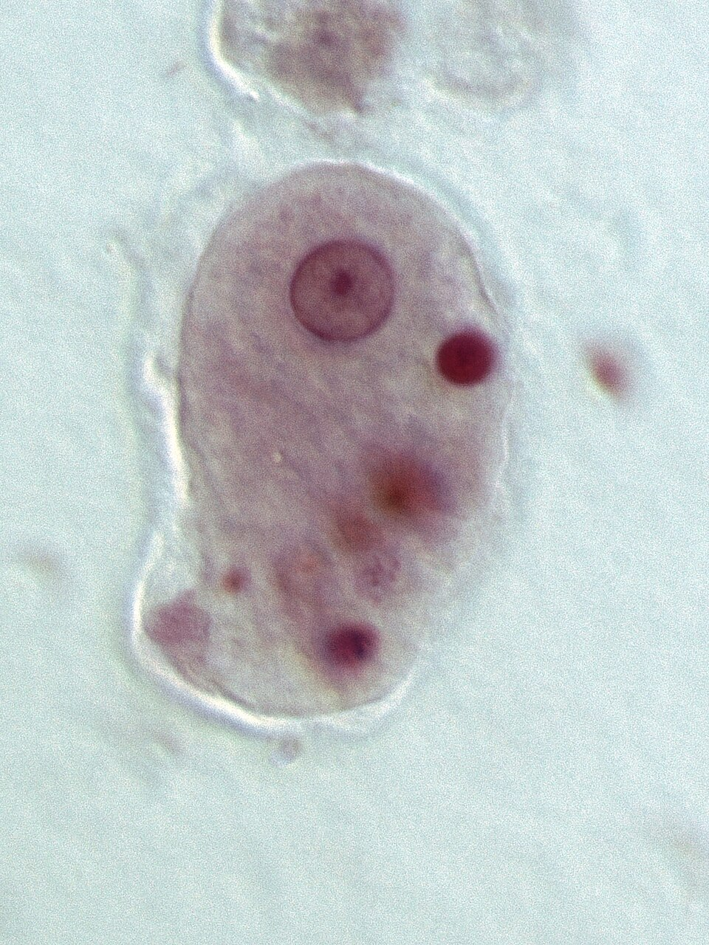

### **Acanthamoeba spp.**

* **Epidemiology**: Free-living amoeba in soil, water, contact lens solutions.
* **Transmission**: Traumatic inoculation into cornea; inhalation/cutaneous entry → CNS (immunocompromised).
* **Clinical**:
  + **Keratitis**: severe, painful, ring infiltrates in contact lens wearers; often misdiagnosed as HSV keratitis.
  + **Granulomatous amoebic encephalitis (GAE)**: subacute/chronic in immunocompromised; weeks–months.
* **Diagnosis**: Corneal scrapings: culture on non-nutrient agar with *E. coli* overlay; PCR; confocal microscopy.
* **Treatment**:
  + Keratitis: prolonged topical therapy (biguanides, diamidines, ± azoles).
  + GAE: multi-drug regimens (miltefosine, pentamidine, azoles, flucytosine, macrolides). Poor prognosis.

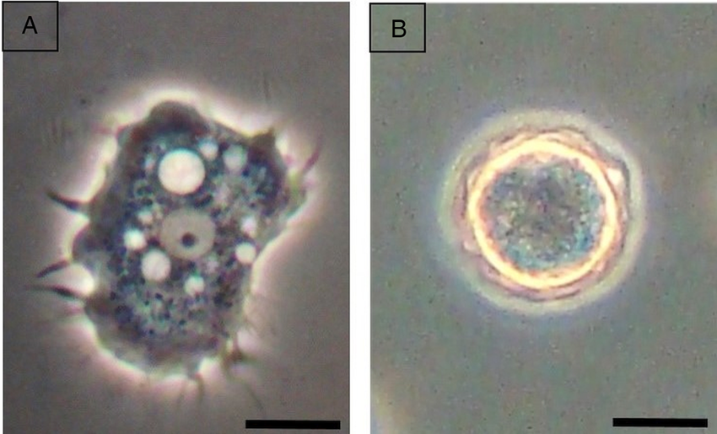

### **Naegleria fowleri**

* **Epidemiology**: Free-living; warm freshwater lakes/rivers, poorly chlorinated pools. Rare but fulminant.
* **Transmission**: Water forced into nasal passages → olfactory mucosa → CNS. *Not by ingestion.*
* **Clinical**: Primary amoebic meningoencephalitis (PAM): acute, rapidly progressive; death in days.
* **Diagnosis**: CSF: neutrophilic pleocytosis, ↓ glucose, ↑ protein; wet mount: motile trophozoites (distinguishes from *Acanthamoeba*); PCR confirmation. Culture possible on non-nutrient agar with bacteria, though rarely used.
* **Treatment**: Amphotericin B (IV + intrathecal), rifampicin, azoles, miltefosine; early aggressive therapy + hypothermia sometimes successful. Mortality >95%.
* **Prevention**: Avoid nasal exposure to warm freshwater; proper pool chlorination.
* 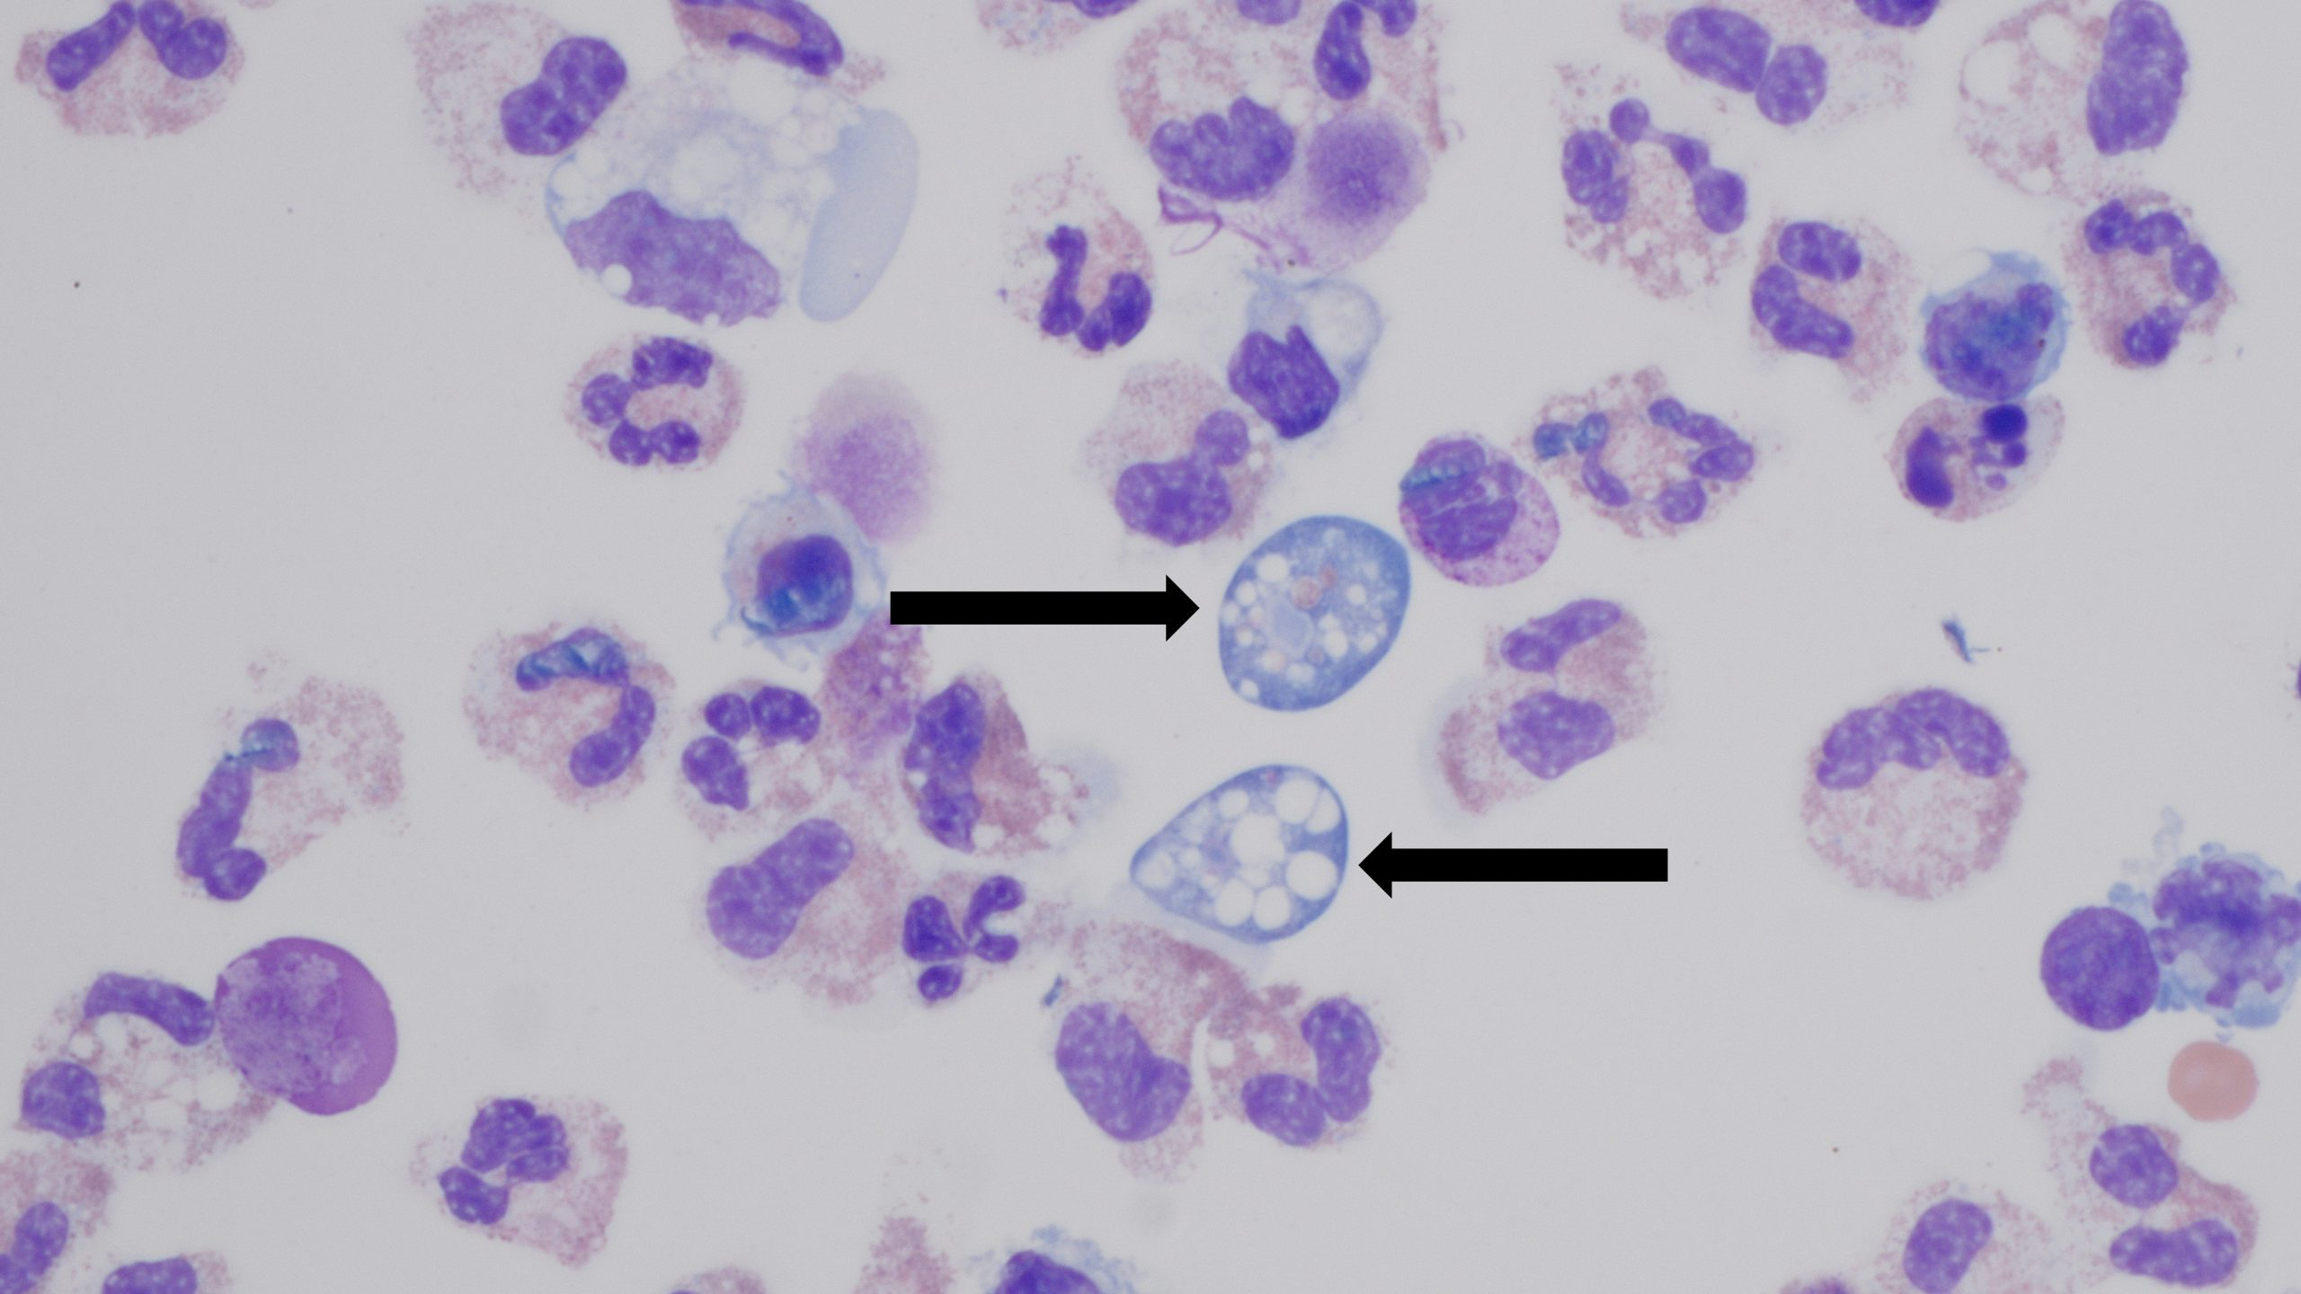

### **Balamuthia mandrillaris**

* **Epidemiology**: Rare; soil exposure.
* **Transmission**: Inhalation or skin → CNS.
* **Clinical**: Granulomatous amoebic encephalitis; cutaneous lesions.
* **Diagnosis**: Histology (amoebic trophozoites and cysts), PCR.
* **Treatment**: Multi-drug regimens (miltefosine, azoles, macrolides, flucytosine); prognosis poor.

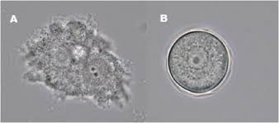

## **Intestinal Protozoa**

### **Giardia lamblia (intestinalis, duodenalis)**

* **Epidemiology**: Worldwide; waterborne outbreaks, esp. travellers/children.
* **Transmission**: Ingestion of cysts from contaminated water/food.
* **Clinical**: Malabsorptive diarrhoea, bloating, steatorrhoea; chronic infection → growth failure in children.
* **Diagnosis**: Stool microscopy (trophozoite with “falling leaf motility”); antigen detection ELISA, PCR; string test (Entero-test) is a classical though rarely used method.
* **Treatment**: Metronidazole, tinidazole, or nitazoxanide.

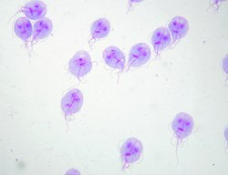 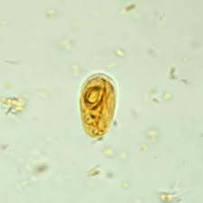

### **Cryptosporidium (C. hominis, C. parvum)**

* **Epidemiology**: Worldwide; zoonotic reservoirs. Oocysts chlorine-resistant → waterborne outbreaks.
* **Transmission**: Ingestion of oocysts (faeco-oral, contaminated water, animal contact). Oocysts are immediately infectious on excretion.
* **Clinical**:
  + Immunocompetent: watery diarrhoea, self-limited.
  + Immunocompromised: chronic diarrhoea, biliary/pancreatic involvement.
* **Diagnosis**: Modified Ziehl–Neelsen (acid-fast oocysts 4–6 μm); antigen assays; PCR.
* **Treatment**: Supportive; nitazoxanide (variable efficacy); optimise ART in HIV.
* **Infection control**: Strict hygiene, water filtration; chlorine insufficient.

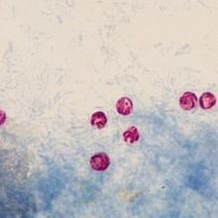

### **Cyclospora cayetanensis**

* **Epidemiology**: Tropics/subtropics; foodborne outbreaks (berries, salad).
* **Transmission**: Ingestion of oocysts (require sporulation outside host to become infectious).
* **Clinical**: Relapsing/prolonged watery diarrhoea, esp. in travellers or immunocompromised.
* **Diagnosis**: Variable acid-fast oocysts (8–10 µm, larger than *Cryptosporidium*); autofluorescence; PCR.
* **Treatment**: Co-trimoxazole.

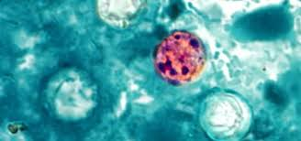

### **Cystoisospora (Isospora) belli**

* **Epidemiology**: Rare; immunocompromised (HIV).
* **Transmission**: Ingestion of oocysts (require sporulation outside host to become infectious).
* **Clinical**: Watery diarrhoea, malabsorption, weight loss.
* **Diagnosis**: Large acid-fast oocysts (20–30 µm, larger than *Cryptosporidium* and *Cyclospora*); PCR.
* **Treatment**: Co-trimoxazole.

### **Balantidium coli**

* **Epidemiology**: Rare; zoonosis (pigs).
* **Transmission**: Ingestion of cysts (faeco-oral).
* **Clinical**: Dysentery-like illness; colitis.
* **Diagnosis**: Large ciliated trophozoites in stool.
* **Treatment**: Tetracycline; alternatives: metronidazole, iodoquinol.

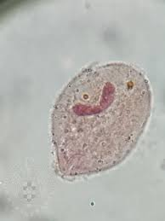

## **Urogenital Protozoa**

### **Trichomonas vaginalis**

* **Epidemiology**: Worldwide; common STI.
* **Transmission**: Sexual contact.
* **Clinical**:
  + Women: vaginitis, frothy discharge, “strawberry cervix.”
  + Men: urethritis, prostatitis (often asymptomatic).
* **Diagnosis**: Wet mount (motile trophozoites, “jerky motility”); antigen/PCR.
* **Treatment**: Metronidazole or tinidazole (treat partners).

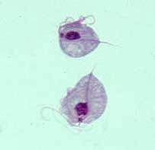

## **Blood & Tissue Protozoa**

### **Plasmodium spp. (falciparum, vivax, ovale, malariae, knowlesi)**

* **Epidemiology**: Endemic in tropics/subtropics.
* **Transmission**: *Anopheles* mosquito.
* **Clinical**: Malaria: cyclical fever, anaemia, splenomegaly; *falciparum* → severe malaria (cerebral, renal failure, acidosis). *Vivax* and *ovale* can relapse due to dormant hypnozoites in liver.
* **Diagnosis**: Thick/thin blood films (species ID); rapid diagnostic tests; PCR.
* **Treatment**:
  + Uncomplicated: artemisinin-based combination therapy (ACT).
  + Severe: IV artesunate.
  + Primaquine required to eradicate hypnozoites (*vivax*/*ovale*).
* **Prevention**: Chemoprophylaxis, vector control.

### **Babesia (B. microti, B. divergens)**

* **Epidemiology**: Tick-borne (Ixodes). *B. microti* (US); *B. divergens* (Europe, severe in splenectomised).
* **Transmission**: Tick bite; transfusion; rarely congenital.
* **Clinical**: Malaria-like fever, haemolysis; severe in splenectomised, elderly, immunocompromised.
* **Diagnosis**: Blood film: intraerythrocytic rings, Maltese cross tetrads; lacks haemozoin pigment (unlike malaria). PCR; serology.
* **Treatment**:
  + Mild: atovaquone + azithromycin.
  + Severe: clindamycin + quinine; exchange transfusion if high parasitaemia.
* **Prevention**: Tick avoidance; donor blood screening.

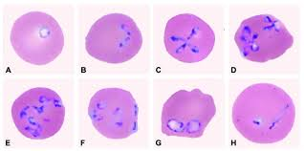

**Trypanosoma brucei (gambiense, rhodesiense)**

* **Epidemiology**: Sub-Saharan Africa; vector: tsetse fly (*Glossina*).
* **Transmission**: Bite of infected fly.
* **Clinical**: African trypanosomiasis (“sleeping sickness”):
  + Chancre at bite site.
  + Haemolymphatic stage: fever, lymphadenopathy (Winterbottom’s sign).
  + CNS stage: somnolence, confusion, coma.
* **Diagnosis**: Blood/CSF microscopy (trypomastigotes); serology (CATT test for *T. b. gambiense*).
* **Treatment**:
  + **New:** Fexinidazole is an oral nitroimidazole recently licensed for all stages of *T. b. gambiense* sleeping sickness.

|  |  |  |
| --- | --- | --- |
|  | gambiense | rhodesiense |
| Early | pentamidine | suramin |
| CNS | eflornithine ± nifurtimox | melarsoprol |

* **Additional note**: Pathogenesis involves antigenic variation of surface glycoproteins.
* **Key differences:**
  + *T. b. gambiense*: West/Central Africa, chronic disease (months–years), human reservoir, more common; CNS involvement late; better prognosis.
  + *T. b. rhodesiense*: East/Southern Africa, acute/rapid course (weeks), zoonotic reservoir (cattle, game), more severe, early CNS involvement; high mortality if untreated.

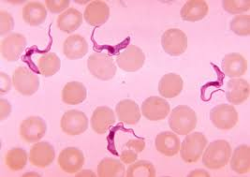

### **Trypanosoma cruzi**

* **Epidemiology**: Latin America; vector: reduviid “kissing bug.”
* **Transmission**: Contamination of bite by vector faeces; transfusion; congenital.
* **Clinical**:
  + Acute: fever, chagoma, Romana’s sign (periorbital oedema).
  + Chronic: cardiomyopathy, arrhythmia, megaoesophagus, megacolon.
* **Diagnosis**: Acute: blood film (trypomastigotes). Chronic: serology, PCR. Xenodiagnosis is a traditional though rarely used method.
* **Treatment**: Benznidazole or nifurtimox (more effective in acute).

**Leishmania spp.**

* **Epidemiology**: Mediterranean, Middle East, Asia, South America; vector: sandfly.
* **Transmission**: Bite of infected sandfly.
* **Clinical**:
  + **Visceral leishmaniasis (kala-azar)**: fever, weight loss, hepatosplenomegaly, pancytopenia.
  + **Cutaneous leishmaniasis**: localised skin ulcers at bite site.
  + **Mucocutaneous leishmaniasis**: destructive mucosal lesions (nasopharyngeal).
* **Diagnosis**: Amastigotes (Leishman-Donovan bodies) in macrophages; PCR; serology; rk39 antigen test used for visceral disease.
* **Treatment**:
  + **Visceral leishmaniasis**: liposomal amphotericin B (first-line); alternatives: miltefosine, pentavalent antimonials (resistance in India).
  + **Cutaneous leishmaniasis**: often self-limiting; local therapies (cryotherapy, intralesional antimonials); systemic treatment (miltefosine, amphotericin B) for severe, disseminated, or mucocutaneous disease.

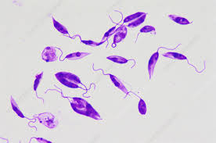

## **Zoonotic / Opportunistic Protozoa**

### **Toxoplasma gondii**

* **Epidemiology**: Worldwide; cats are definitive hosts.
* **Transmission**: Ingestion of oocysts (cat faeces) or tissue cysts (undercooked meat); congenital.
* **Clinical**:
  + Immunocompetent: mild flu-like, lymphadenopathy.
  + HIV: encephalitis (multiple ring-enhancing brain lesions).
  + Congenital: triad (chorioretinitis, hydrocephalus, intracranial calcifications).
* **Diagnosis**: Serology (IgM/IgG, avidity); PCR (blood, CSF); imaging in HIV.
* **Treatment**: Pyrimethamine + sulfadiazine + folinic acid. Spiramycin in pregnancy to reduce congenital transmission.

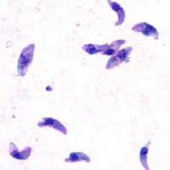

### **Microsporidia (Enterocytozoon bieneusi, Encephalitozoon spp.)**

* **Epidemiology**: Opportunistic, esp. HIV/immunosuppressed.
* **Transmission**: Ingestion or inhalation of spores.
* **Clinical**: Chronic diarrhoea, wasting; keratitis; disseminated disease.
* **Diagnosis**: Modified trichrome stain; EM; PCR. Spores are very small (1–2 μm).
* **Treatment**: Albendazole (variable species activity); ART in HIV.

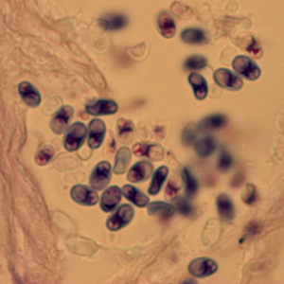

# **Key Buzzwords for Exams**

* *Entamoeba*: “anchovy sauce pus.”
* *Giardia*: “falling leaf motility.”
* *Cryptosporidium*: “acid-fast oocysts, swimming pools.”
* *Cyclospora*: “autofluorescent oocysts.”
* *Cystoisospora*: “large acid-fast oocysts.”
* *Balantidium*: “large ciliate trophozoite.”
* *Trichomonas*: “strawberry cervix.”
* *Plasmodium falciparum*: “banana-shaped gametocyte.”
* *Babesia*: “Maltese cross; no pigment.”
* *T. brucei*: “Winterbottom’s sign; antigenic variation.”
* *T. cruzi*: “Romana’s sign.”
* *Leishmania*: “amastigotes in macrophages.”
* *Naegleria*: “motile trophozoites in wet CSF.”
* *Acanthamoeba*: “ring infiltrate keratitis.”
* *Toxoplasma*: “ring-enhancing brain lesions in HIV; spiramycin in pregnancy.”
* *Microsporidia*: “tiny 1–2 μm spores.”